Nuclear Reactions and Decay

Name
Instructor
Course
Institution
Date

Nuclear Reactions and Decay
1) Nuclear fission and fusion are radioactive reactions that occur between particles such as atoms. Nuclear fusion refers to a response where to more atomic nuclei combine to form different nuclei and other subatomic particles. Nuclear fission refers to the breakdown of a hearts into two or smaller atoms and particles. Nuclear fusion occurs naturally as compared to fission. This is evidenced by the sun's radiations which reaches the earth. The sun comprises high temperatures and pressure, which initiate the reaction.
Similarities
- Both reactions use the energy stored in the atomic particles involved. The presence of subatomic particles contributes to this. These are neutrons, protons and electrons.
- Both reactions can be used to produce energy. The breaking down or combination of atoms results in the release of enormous power since both are exothermic reactions
- This reaction occurs at the centre more of an atom known as the nucleus, which gives them the name nuclear reactions.
Differences
- Nuclear fission, by definitions, refers to the bombarding of a nucleus to create smaller atoms. In contrast, atomic fusion recombination of two atoms produces different nuclei and subatomic particles.
- Atomic bombs are made on the principles of nuclear fission, while hydrogen bombs are based on nuclear fusion.
- The amount of energy produced on nuclear fission is a fraction of the energy produced in nuclear fusion.
- Fusion occurs naturally, which is evident in stars and the sun, while fission does not.
- Light beams are needed to break the atom in fission reactions, while fusion reactions require high energy input to combine the atoms.
2) Sodium 24(Na) decay scheme
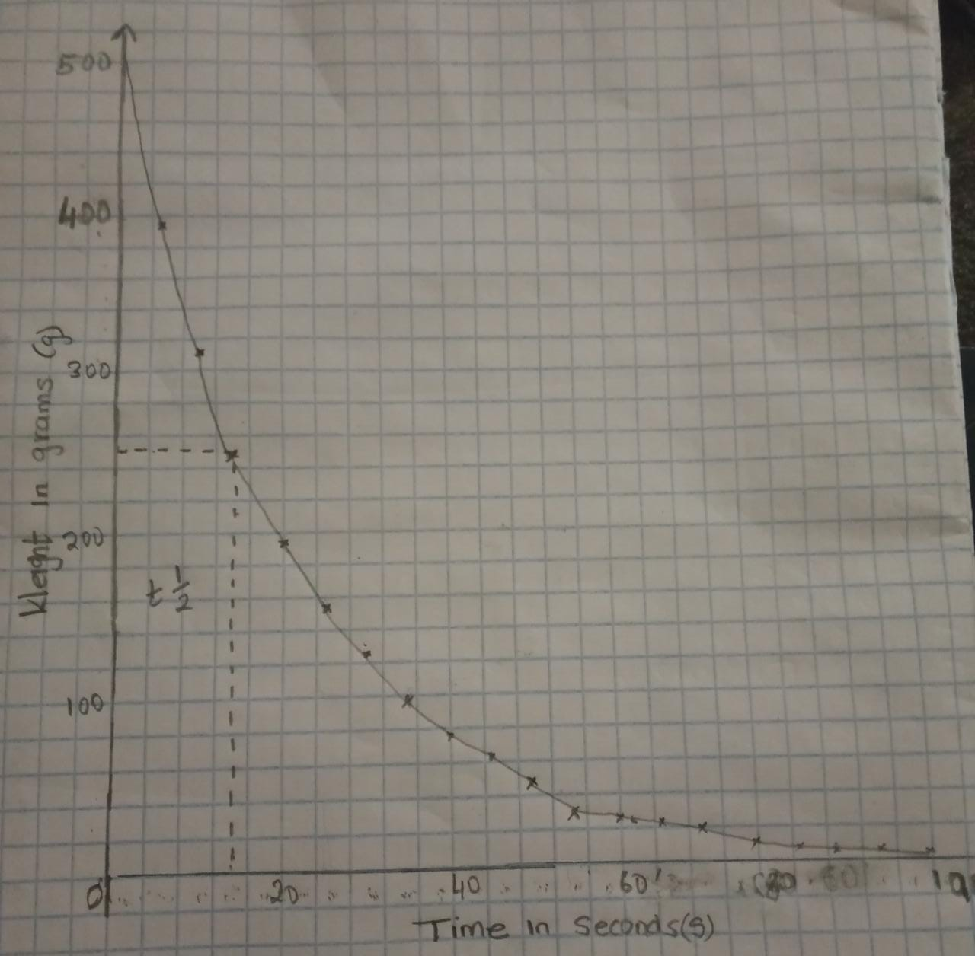
Graph of time(s)(x-axis) against weight(g)(y-axis)
ii) The formula for calculating the half-life of atom regarding time and weight follows for time against weight shows that the half-life for Na 24 is 14.8 seconds. This is determined by looking at the graph when half of 500 grams had decayed and extending a line to the corresponding time in seconds,
iii) Beta decay of Na 24
24. A. 0
Na ->. X. +. B. +Ve-
11. Z. -1
A=24-0
=24. Thus the nuclear reaction for Na 24 is

Z=11--1. 24. 24 0
=12 Na ->. Mg + B. +Ve-
11. 12 -1

3)
i)The nucleus
The nucleus of every atom is located at the centre. Inside the nucleus are two types of neutrons whose number varies depending on the atoms. TheseThese' nucleus protons are positively charged particles and neutrons, have no charge at all. The stability of the atom is dependent on the composition of the nucleus. The neurons function to prevent the forces of repulsion within the fraction arising from the protons.

E.L
Core/nucleus Containing neutrons net charge 0 and protons net amount (+)

Energy Levels
ii) Force involved in holding the nucleus together. This is the strong nuclear force that is greater in magnitude compared to the electromagnetic force of repulsion that helps prevent the repulsion of protons within the nucleus due to their positive charge. This force pulls the neutrons and protons together, creating a compact. It promotes the stability of the nucleus and the whole atom

Key
Protons
Neutrons
The figure shows the actions of the strong nuclear force in the nucleus.
iii) Beta emission or decay is a nuclear reaction that occurs in an atom that involves the protons and neutrons. The reason is that there are too many protons and neutrons in the nucleus, making it possible to reduce either. Beta emission results in the breaking down a neutron into a proton or a proton breaking down to form a neutron. These two types of Beta emission can be plus or minus. Plus, beta emission involves proton decaying into a neutron, positron and antineutrino. Minus beta emission consists of the neutron decay into a proton, positron and neutrino. The energy of this reaction is released in the emission and the particles produced.
4)
i) Fission reaction
Fusion reaction a radioactive process that involves the bombardment of two or more atoms to create fission products. These products are smaller than the original atom. This reaction is an exothermic process, and its application is in large atoms whose strong nuclear force is less potent in large particles. In the initiation of the reaction, the particle is bombarded by a neutron to produce an unstable isotope beginning a chain reaction.
ii) The most commonly used isotope in nuclear fission is uranium 235.
iii) Working of a nuclear power plant
A nuclear power plant is an industrial firm that produces electricity from nuclear reactions. Nuclear reactions have thermal energy. The main component of the production is the fuel which is the Uranium 235 isotope. There are two types of power plants viz; pressurised water reactor and boiling water reactor. The thermal energy produced in the nuclear reactor from the bombardment of uranium 235 is used to boil water. The steam produced is then used go to turbines which produce electric power. This is a form of energy production that has taken prominence in the modern world and suitable for producing clean energy.

